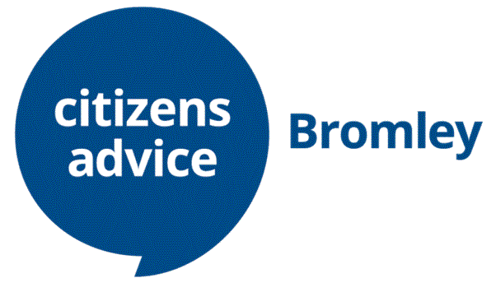

**Job Description**

**Single Point of Access Telephone Assessors**

Our Single Point of Access telephone line takes calls from Bromley residents who are looking for help, advice and support.

Our SPA Telephone Assessors take the initial calls from clients, identify the issue/issues requiring help and direct them to the appropriate source of support; this could be to Citizens Advice Bromley, Age UK Bromley & Greenwich, Bromley Mencap and Bromley, Lewisham & Greenwich Mind, or other local agencies. Telephone assessors then record the conversation on an online database.

A clear telephone manner is required, as well as the ability to speak with clients calmly and empathetically, as well as experience of handling telephone calls in a busy environment.

You will also need a good level of IT skills, as you will be required to enter client conversations on an online database, and have knowledge of Microsoft Outlook, Excel and Word.

Commitment - 1 day (or two half days) a week for minimum of 4 months. Training takes about around 1 month.